**Abstraction in Java**

Abstraction is the important pillars of the **O**bject-**O**riented **P**rogramming Concepts

The General Meaning of Abstraction is ‘**the quality of dealing with ideas rather than events’**

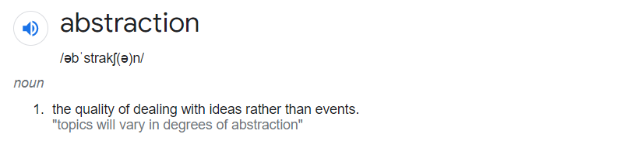

**Real file example of Abstraction:** ATM ( it’s a typical example I have heard from my college days 😊)



We can do different operations/type of transactions like **Cash withdraw, Balance Check, Cash Deposit** at ATM but we don’t know how ATM works internally.

**How to Achieve Abstraction**

Abstraction can be achieved in two different ways:

1. Using abstract classes
2. Using interfaces

**Let’s see what is Abstract Class:**

An Abstract class contains one or more abstract methods along with Concrete methods ( Normal methods)

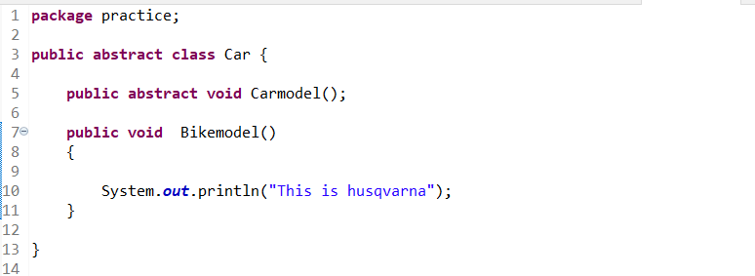

**Set of rules to follow for Abstract Class:**

1. Once we declare a class as an abstract class we cannot instantiate the class, meaning we cannot create an instance(object) of the abstract class.

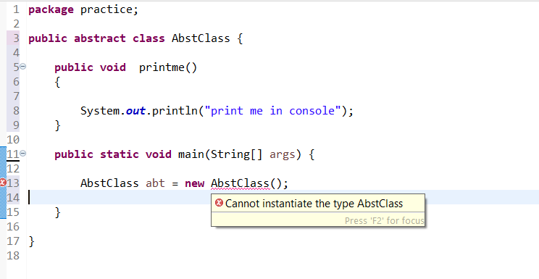

1. To define a class as an abstract class we have to use the ‘abstract’ keyword with the class name.



**How to use Abstract Class**

To use an abstract class, we need to extend it to another class and provide

the definition to all the abstract methods declared to that class else the new class also needs to be declared as abstract.

**Class 1 Vehicletypes**

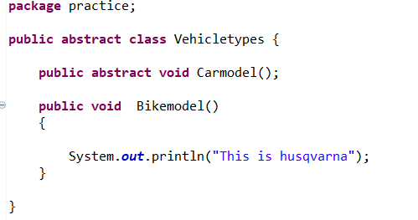

**Class 2 Vehicle extends Class 1 Vehicletypes**

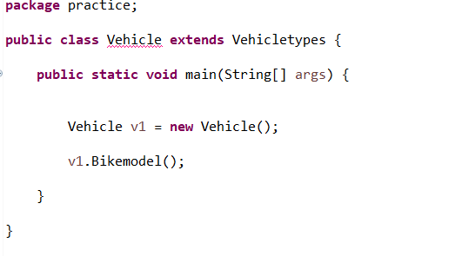

Class 1 Vehicletypes contains 2 methods ( Bikemodel and Carmodel ) we didn’t implement abstract method Carmodel we are getting the below error

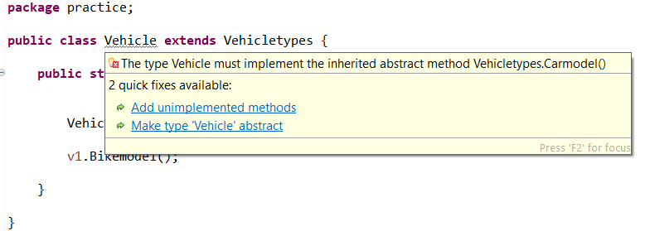

To overcome the above error we should implement the abstract method

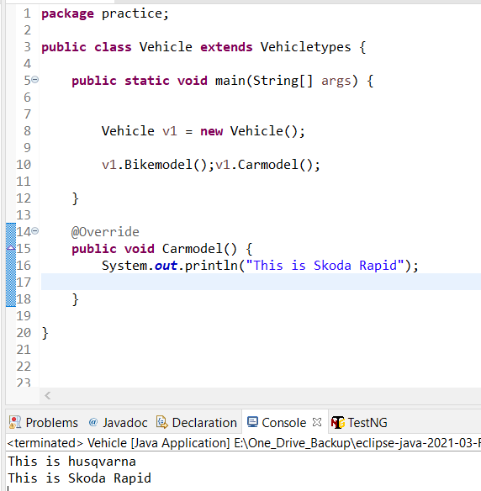

**Abstraction Using Interfaces:**

An interface is a set of abstract methods, static methods, and static constants.

* Each method is by default public and abstract.
* It does not contain any constructor.
* Each variable declared in an interface is by default public, static, and final.
* Similar to abstract classes we cannot create instances of interfaces.

Along with abstraction, the interface helps to achieve **multiple inheritances in Java.**

**Television as an Interface:**

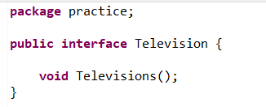

**Electronics as a Concrete class which implements Television Interface**

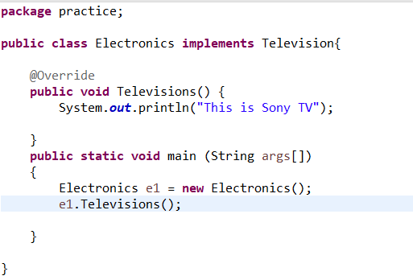

**Note:**

* **We can achieve 100% abstraction using interfaces.**
* **Through abstract classes we can achieve 0–100% abstraction as the abstract classes may contain concrete methods.**